Roald Medendorp

CSD-310 Module 6.2

Bellevue University

6/24/2024

https://github.com/Roald-Niels/csd-310

Step 1

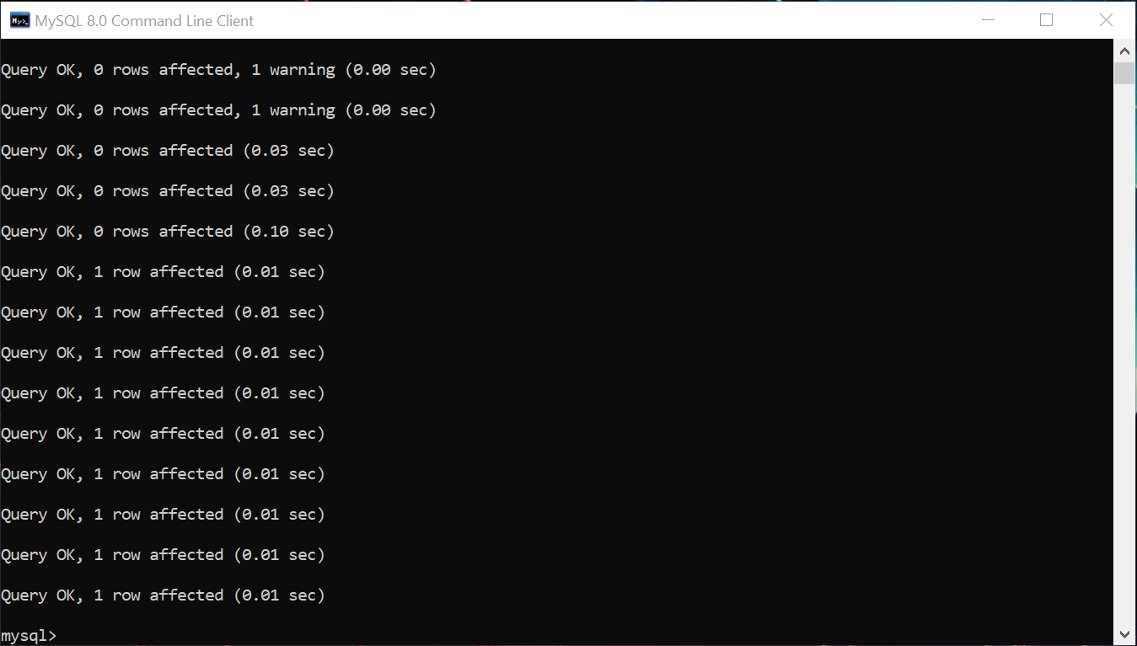

Step 2

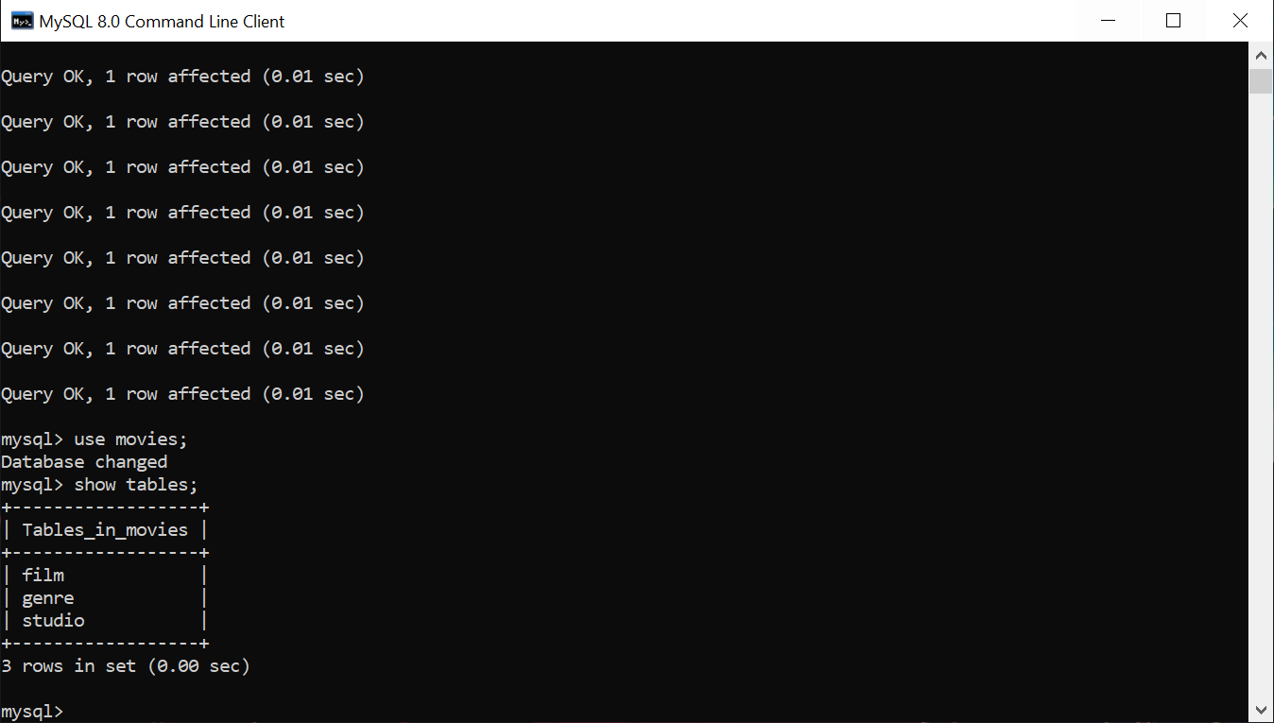

Step 3 – I had issues connecting to the SQL Server. I was not able to receive a response in time so submitted the error codes that came up.

